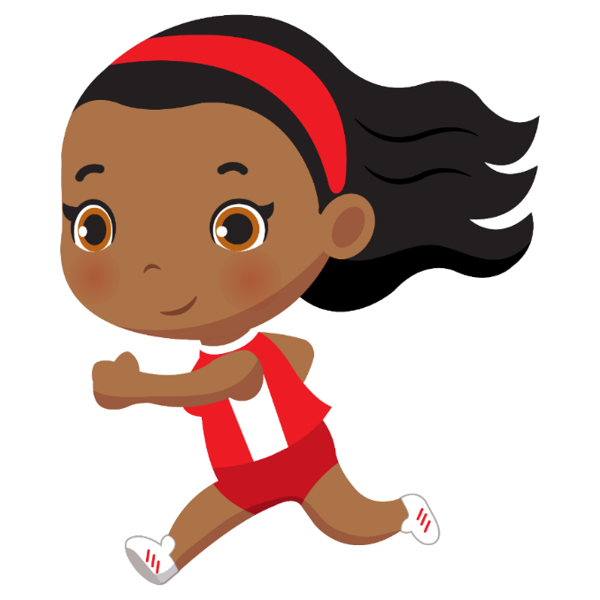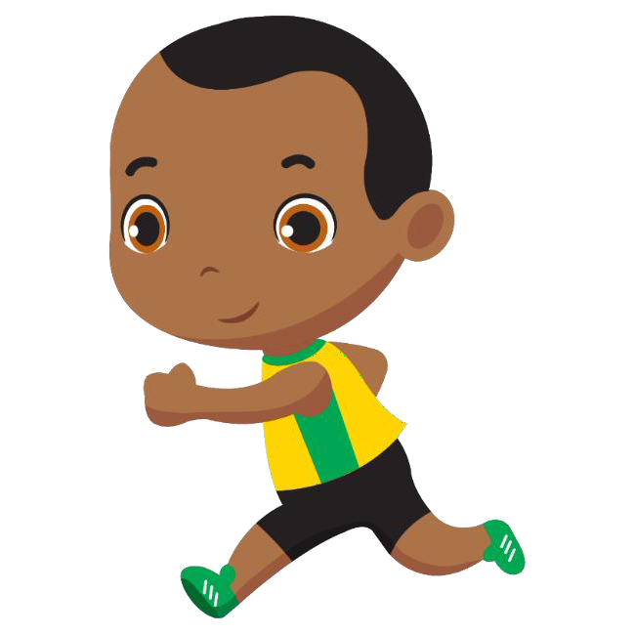Water Dash

Use a cup of water to take the water from one bucket to the other.

Bean Bag Toss

Try to throw the bean bags into the matching colour rings.

Egg and Spoon Race

Carry an egg on a spoon from the starting line to the finish.

Long Jump

How far can you jump?

Running

How fast can you run to the finish line?

Skittles

Try to knock over all the skittles.

Bubble Popping

How many bubbles can you pop?

Bean Bag Balance

Put a bean bag on your head and walk to the finish line.

Write your own activity.

Type the description here.

