INTERNATIONAL DAY OF SIGN LANGUAGES

SPECIAL DAYS

PREPARATION

- If you have someone in your wider church family who is deaf and uses British Sign Language (BSL), invite them to come and teach the group some signs and the verse from John 3:16
- Familiarise yourself with these videos and resources:

Watch a video by The Deaf Academy on how to fingerspell the alphabet

Visit BritishSign.com for printable charts on fingerspelling the alphabet

Watch a video by Bourne Salvation Army to learn how to sign some greetings and John 3:16

INTRODUCTION/BACKGROUND

Around the world there are roughly 72 million people who are deaf or hearing impaired, and collectively they use more than 300 different sign languages, each one being a fully-fledged, natural language.

While sign languages may be structured differently from spoken language, they are to be given just as much credit and importance. They have developed regionally, just as vocal languages have, and so vary by country and often by locality within a country. Just as spoken English varies around the UK and Ireland, there are many regional variations of BSL.

International Day of Sign Languages (September 23) celebrates all these amazing sign languages, paying homage to the incredible difference they have made to deaf people all around the world and increasing awareness about them.

ACTIVITIES

SIGNING
Teach members how to:

- fingerspell the alphabet,
- fingerspell their name,
- sign some greetings, and
- sign a Bible verse, John 3:16.

Ask your visitor to help teach these to your group; or use the printable BSL alphabet charts, the BSL Alphabet video and the Let’s Learn Some Signs video which includes John 3:16.

Here are the greetings and Bible verse featured in the video:

- Hello.
- How are you?
- I am well.
- Nice to see you.
- Can I help?
- I am deaf.
- I am hearing.
- I can fingerspell.
- My name is …

- ‘God so loved the world, that he gave his only son so that everyone who believes in him can have everlasting life.’

(John 3:16 paraphrased)

BIBLE READING/THOUGHT

When we look at our universe and see all the variance in it – the different planets and stars; the different plants and animals; the different places and people – we must recognise the creativity and love of variety of God our creator. Indeed, throughout Scripture we read of this. Psalm 104:24-25 says:

- ‘How many are your works, Lord!

In wisdom you made them all;

the earth is full of your creatures.

There is the sea, vast and spacious,

teeming with creatures beyond number –

living things both large and small.’

Yes, God loves variety, and we see this throughout this tiny planet on which we live. We also see it in the people on this world. We are all, as we read in Genesis, made in the image of God – loved and valued by our creator – yet within this there is a spectrum so wide and varying it is beautiful to see. Humanity is made up of so many kinds of people, with differences both obvious and hidden.

One way that we vary is through our language. Across our world there are more than 7,000 vocal languages – plus the addition, as we are realising today, of approximately 300 signed languages. How amazing are the variations and nuances of language! When it comes to signed languages, the beauty of sharing language, not just with your vocal cords, but indeed with your whole body, is breathtaking.

God created us all in his image, yet different, and we acknowledge his craftsmanship in the case of language.

Despite, or perhaps because of, all our differences, we can acknowledge that God sent his son not just for this kind of person or that kind of person, but for all kinds of people. God loves each one of us without measure – loves our similarities and adores our differences. As we praise our creative God, let us recognise and cherish our differences, because we are loved, just as we are.

SONGS

- SASB 276 ‘Thine is the glory’
Watch the BSL lyric video by Christian BSL.com
- SASB 453 ‘Amazing Grace!’
Watch the BSL lyric video by Christian BSL.com
- ‘The Blessing UK’ (A Benediction)
Watch the BSL lyric video by CFC Sign Language

WEBSITE AND CONTACT DETAILS

- Connect website: www.salvationarmy.org.uk/connect
- Family Ministries website: www.salvationarmy.org.uk/families
- Emails: familyministries@salvationarmy.org.uk
- Facebook: @sarmyfm
- Twitter: @ukifamily
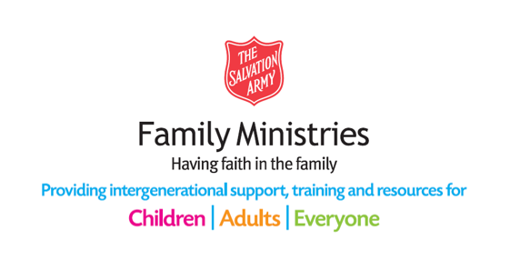
- Instagram: safamily_ministries

