INTERNATIONAL DAY OF YOUTH
SPECIAL DAYS

PREPARATION
- Prepare to show the video Aim Lower (2020)
- Prepare a quiz on successful youths (see below)
- Find a piece of reflective music for prayer activity
- Provide paper and pens

- In advance email the quiz sheet (optional)
- Ask members to have a pen and paper
Additional resource:
- How Old?! Quiz
Be sensitive in case reflecting on childhood is a difficult theme for some members.

INTRODUCTION/BACKGROUND
The United Nations commemorates International Youth Day on 12 August. It is a day to highlight cultural and legal issues that today’s youth face and to celebrate their achievements.

‘The success of such a global effort will not be achieved without the meaningful participation of young people.’

United Nations for Youth

The strength and the challenge around International Youth Day is that the driver for the event is the full and meaningful participation of young people. The organisers believe passionately that young people have a right to shape the here and now and also the future. This is a real strength and helps to prioritise the importance of young people.

This presents a challenge and also an example to The Salvation Army. How do we prioritise young people and give them a voice and full participation in the lives of our corps, churches or programmes?

As we focus on young people on this day, it provides a space to think about the young people we are connected to, both within our corps or churches, our lives and the wider communities.

ACTIVITIES

SHARE
Ask members to remember what life was like when they were 11 years old.
Remember to be sensitive in case reflecting on childhood is a difficult theme for some members.
- Encourage members to share their experiences, including:
- What Christmas and birthday presents did you receive?
- Where did you go on holiday or for a day trip?
- What food did you eat?
- What was your favourite toy?
- What was your favourite activity?
Now ask members to answer the same questions for any young people they know.
Spend time sharing about how our worlds have changed, how life is so different now from what it was.

STORY

There are times when we look around our corps or church and think that we don’t have any young people attending. Sometimes we forget that we are actually connected to many young people – through our families and our friends.

There’s a story about a church pastor who was new in her appointment. The church had no children attending and whatever they did, they couldn’t seem to attract any.

One Sunday morning an older gentleman was very upset. He shared with the congregation how his two-week-old granddaughter was facing heart surgery. The pastor, before going into ministry, had been a nurse on a unit that cared for babies who had been born with heart defects. She knew the immense cost to families in these situations. She not only encouraged the congregation to pray into this situation but rallied them to respond practically. This young family were loved and supported and cared for by the church.

This started a ministry to families who were struggling. They cared without expecting anything in return. Interestingly, however, young families started to attend the church. At times we have to change our focus and look at things differently. We want people to come to us, but actually we need to go to them.

DISCUSS

Discuss how the group can support young people in your community. Here are some suggestions:

Pray

Perhaps as a group you could pray specifically for your local school. Send them a card and let the staff know you are praying for them. You will be surprised how much that simple act can encourage a school.

Volunteer

Perhaps individuals could offer to volunteer in a local school. It could be in a primary school, listening to children read. It could be in a secondary school as a mentor. The Salvation Army is developing a schools-based mentoring programme – Starfish – and there may be opportunities through this programme to volunteer as a mentor and journey alongside a young person. (NB The school will require police checks for volunteers.)

Corps/Church

Young people within our corps need support too. It could be through helping in Sunday school / youth and children’s clubs. If members play an instrument, they could share that skill. Some corps run a prayer partner scheme, and you could be involved with that. It’s a great scheme for building those connections in our congregations. If you want to support families, then helping at a parent-and-toddler group would be a great place to start (again, checks are required). Talk to your corps officers and youth and children’s leaders to see if there is any way you can support them.

VIDEO

Inspire your group to work in partnership with young people with this video: Aim Lower (2020) by Global Children’s Forum (2mins 18secs)

Share screen the video.

QUIZ

Use the How Old?! Quiz (see below). Do you know what these people achieved when they were young? You may wish to adapt the quiz, asking members to guess how old these people were when they …

Read the questions out loud or email the questions in advance.

BIBLE READING/THOUGHT
Matthew 19:13-15

For young people today, their worlds are dominated by technology and social media. It has been said that connection on social media is one of the main things that young people crave, and yet at times it is also the thing that does them the most damage.

Young people long for connection – which can indeed be found through social media, but actually what they long for is real-life connection. If the Covid pandemic has taught us anything, it’s the fact that we all long for connection with each other. We recognise and value the power of relationship even more.

‘God is hidden no more,
He has spoken his mind,
Wrapped the gift of his love in the stuff of mankind.
Now his nature is known,
God is love undefiled,
And his love is revealed in the face of a child.’
John Gowans

Many of us will know that the verse is referring to Jesus as a child – Jesus who came and lived among us and ‘moved into the neighbourhood’ (John 1:14 MSG). But it can also refer to all young people: that God’s love is revealed in them – in who they are, in what they do. We can learn about God when we are with young people. And we can learn more about God’s work in us when we are with them too – for example on those occasions when they might test our patience and we have to keep praying for that extra dose of grace!

In the Gospel accounts, Jesus has a lot to say about children. Firstly, what we have to remember is that in society at that time children were very low in the pecking order – along with the women. They were in many ways classed as possessions.

But Jesus comes along and says: ‘Let the little children come to me, and do not hinder them, for the kingdom of heaven belongs to such as these’ (Matthew 19:14). He then placed his hand on them and blessed them. By his actions he is bringing them to the front and centre of society.

In Matthew 18:2–5 he challenges the disciples by saying: ‘Truly I tell you, unless you change and become like little children, you will never enter the kingdom of heaven. Therefore, whoever takes the lowly position of this child is the greatest in the kingdom of heaven. And whoever welcomes one such child in my name welcomes me.’

These are such powerful words for us to think about today: ‘Whoever welcomes one such child in my name welcomes me.’

The question for each of us to think about is how do we welcome young people? How do we support and carry them and place them at the centre of our corps, remembering that as we do so we are welcoming Christ in our midst?

PRAYER
Ask members to write a list of young people that they know or have some connection with. It may be through The Salvation Army, it may be through family or neighbours.

Play a reflective piece of music, and as the music plays invite each member to read out the list of these young people’s first names and bring them before God. Say a prayer for all the young people and for our connection with them to be a meaningful one.

Play a reflective music video but do not share screen; or play a CD near your microphone – but not too close!

SONGS
- SASB 53 ‘Praise and thanksgiving, Father, we offer’
- SASB 151 ‘Tell me the stories of Jesus’
- SASB 396 ‘There are hundreds of sparrows’
- SASB 55 ‘Praise, my soul, the King of Heaven’
Alternatively, here is a more contemporary version by Emu Music.

WEBSITE AND CONTACT DETAILS
- Connect Website: www.salvationarmy.org.uk/connect
- Family Ministries Website: www.salvationarmy.org.uk/families
- Email: familyministries@salvationarmy.org.uk
- Facebook: @sarmyfm
- Twitter: @ukifamily
- Instagram: safamily_ministries

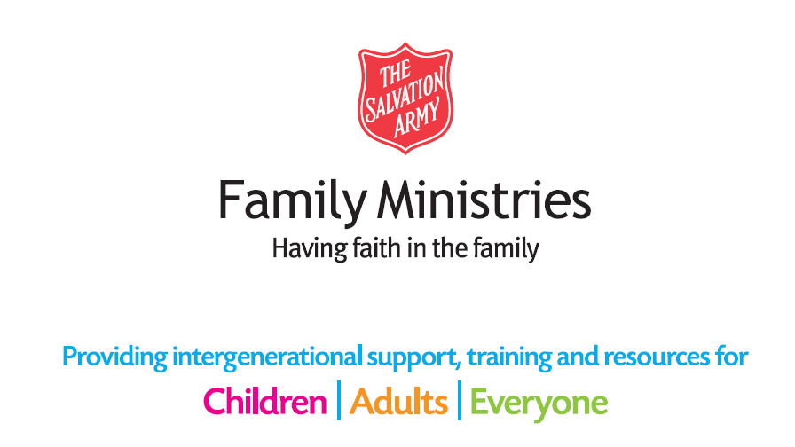

QUIZ

How Old?! Quiz
1. What did Andrew Lloyd Webber do when he was 19?

2. What did Boris Becker do when he was 17?

3. What did Pelé do when he was 17?

4. What did Wolfgang Amadeus Mozart do when he was five (or possibly four!)?

5. What did Richard Branson do when he was 15?

6. What did Sharron Davies do when she was 13?

7. What did Ellen MacArthur do when she was 19?

8. What did Lewis Hamilton do when he was 12?

9. What did Timothy, from the Bible, do when he was young?

10. What happened to Josiah in the Bible when he was eight?

11. What happened to Daniel in the Bible, when he was a teenager?

12. What happened to Mary in the Bible, when she was about 13?

13. What did Amy Carmichael know when she was a young teen?

14. What did James Hudson Taylor say he would be, when he was four?

15. What did David in the Bible do as a young boy?

16. What did William Hague do when he was 16?

17. What did Wayne Rooney do when he was 16?

18. What did Louis Braille do when he was 15?

19. What did Malala Yousafzai win when she was 17?

20. What did Nadia Comăneci receive when she was 14?

QUIZ ANSWERS

How Old?! Quiz Answer Sheet
1. What did Andrew Lloyd Webber do when he was 19?
Wrote a long-running musical (‘Joseph and the Amazing Technicolor Dreamcoat’).
2. What did Boris Becker do when he was 17?
Won the Men’s Singles title at Wimbledon.
3. What did Pelé do when he was 17?
He made his FIFA World Cup football debut for Brazil.
4. What did Wolfgang Amadeus Mozart do when he was five (or possibly four!)?
He started composing his own music.
5. What did Richard Branson do when he was 15?
He started his first two businesses – growing Christmas trees and raising budgies – though both businesses failed.
6. What did Sharron Davies do when she was 13?
She represented the UK in the Montreal Olympics for swimming.
7. What did Ellen MacArthur do when she was 19?
She sailed solo around Britain.
8. What did Lewis Hamilton do when he was 12?
He gained a black belt in karate.
9. What did Timothy, from the Bible, do when he was young?
He was selected for missionary work because of his reputation (1 Timothy 4:12).
10. What happened to Josiah in the Bible when he was eight?
He was crowned King of Judah (2 Kings 22:1).

11. What happened to Daniel in the Bible, when he was a teenager?
He was kidnapped and taken to a foreign land (Daniel 1:3–4,6).
12. What happened to Mary in the Bible, when she was about 13?
She was chosen to be the mother to the son of God (Luke 1:26,27).
13. What did Amy Carmichael know when she was a young teen?
She knew she was to go to India to serve the poor as a missionary.
14. What did James Hudson Taylor say he would be, when he was four?
That he would be a missionary to China.
15. What did David in the Bible do as a young boy?
He took on an enemy that his country’s soldiers were too scared to fight – Goliath (1 Samuel 17).
16. What did William Hague do when he was 16?
He made a speech at Conservative Party conference and was tipped as a leader to watch out for.
17. What did Wayne Rooney do when he was 16?
He became the youngest ever goal scorer in Premiership history (so far!).
18. What did Louis Braille do when he was 15?
He invented the Braille system for reading for the blind.
19. What did Malala Yousafzai win when she was 17?
The Nobel Peace Prize.
20. What did Nadia Comăneci receive when she was 14?
She was the first gymnast to get the perfect score of ten in the Olympic Games.

