**Building Bridges**

By Major Andrea Cooper

Regional Chaplaincy Officer – Central & London Regions

Homelessness Services

*Resources Required:* Bridge Poem Wooden lolly sticks – coloured or plain Pens or pencils

*Introduction*

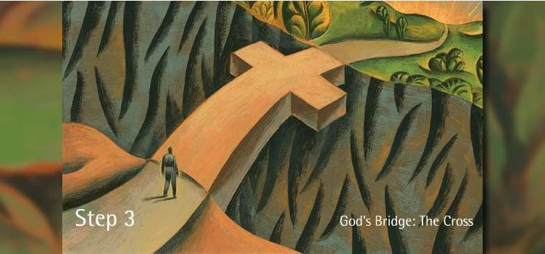

***Source:*** [*Pin on First & Foremost (pinterest.co.uk)*](https://www.pinterest.co.uk/pin/255086766366781785/)

Christ’s death & resurrection opened the way for humanity to be with God. The Cross became our bridge to God & as General John Gowans so beautifully expressed in his poem Bridge, he wanted God to use him, like Jesus, as a bridge, for people to get to know God themselves through his life & ministry.

A Chaplain, whether in prisons, shops, police forces, airports, docks, or Salvation Army services, act as a Bridge-Builder. Their role is simply to demonstrate Christ through their day-to-day ministry, being a living example of Christ – His attitude, behaviour & teaching, through the building of relationships.

A chaplain working in Homelessness Services needs to be daily building bridges between…

* God & People
* Church & World
* Service User & Service User
* Staff Member & Staff Member
* Service User & Staff Member
* Service User & Faith Group
* Service User & family
* Service & Local Community
* Chaplain & Service User
* Chaplain & Staff Team
* Chaplain & Local Community
* Chaplain & faith Groups

Chaplaincy is a vast & varied role, with no two days the same, because they’re working with people. Which brings joy, tears, interruptions, laughter, pain, challenges & affirmation that God has placed them exactly where He needs them. A chaplain can feel isolated, being on their own in situations away from the safety of a group of believers or a church building. They need prayer support, wisdom, encouragement, discernment & God’s strength to do what He wants them to do.

It’s not just Christians who need to be demonstrating Christ in their lives, all believers with the power of the Holy Spirit, need to be living that way. But the reality is that building & maintaining relationships can be difficult, during our prayer time we will focus on chaplaincy, but also on our own relationships with others.

**Song** – SASB 1001 (TB 533) Help Us Build a Loving World

*Prayer Activity*

Whilst singing or listening to the song…

Take a lolly stick, which represents a blank of wood which makes up a bridge.

On one side write a word, name, sentence or draw an image as a prayer for chaplaincy within The Salvation Army. That God will continue to use this beautiful ministry to transform lives & build His Kingdom. It may be a prayer for courage or strength, inspiration or challenge, whatever God is placing on your heart to pray for.

On the other side of the lolly stick, write the name of someone you want to demonstrate Jesus to or build a better relationship with.

As you sing the words, hold the prayer stick in the palm of your hand, praying for the work of chaplains and the relationship God wants you to work on & then ask God to use you as a Bridge Builder in whatever situation you find yourself in.

*Prayer to Close Prayer Time*

*Heavenly Father, as we hold these Prayer Sticks in our hands, protect those we have prayed for, strengthen, guide & love them, let them sense your presence in a special way just now. Lord, help me to be a better Bridge Builder in my life, that as I build relationships with people, help me demonstrate your love & attitude. Hear & answer our prayers Amen.*